DSC 450: Database Processing for Large-Scale Analytics

Take-home Midterm

Nick Jones
Do not forget to include all python code and SQL code in every question.

Part 1

(9 points) Please give a “True” or a “False” rating to each statement below.
a. A schema that is in Second Normal Form (2NF) must also be in Third Normal Form (3NF). FALSE

b. A primary key must be composed of exactly one column. FALSE

c. The union rule allows to combine functional dependencies A→CD and B→CD into a functional dependency AB→CD. FALSE

d. SQL query results are always sorted by the primary key. FALSE

e. A table in a relational database is equivalent of a set of tuples. TRUE

f. A UNIQUE constraint on a column allows insertion of a NULL. TRUE

Part 2

a. (3 points) Write a SQL column definition for PurchaseAmt (just for one column, don’t worry about the rest of the table) that ensures that the purchase amount must be between 0 and 9999.99 (column definition should enforce both the number precision and > 0 requirement).
PurchaseAmt Number(6,2) Check( PurchaseAmt >= 0)

b. (3 points) Write a SQL column definition for Street (just for one column, don’t worry about the rest of the table) that ensures that the street address is up to 10 characters and has to start from letter ‘A’ (hint: CHECK constraint can use LIKE operator).
Street CHAR(10) Check(street LIKE ‘A%)

c. (15 points) The following set of relations records information about university students, courses and assigned grades. The Student relation contains information about the student, including the name (full name is stored in one column), address and their year of graduation. The Course relation records information about courses: course name (primary key), course department and the number of credits provided by the course. Finally, the Grade relation records information about the grades given; CName is the foreign key referring to the primary key of the Course relation and StudentID is the foreign key referring to the primary key of the Student relation. The grades are a numeric value given on a 4-point system.
Student(StudentID, Name, Address, GradYear)

Grade(CName, StudentID, CGrade)

Course(CName, Department, Credits)
For each part below, write a single SQL query.

Q1. Display the list of student IDs and names for the students who graduated within the first 3 years of the program. You can assume that GradYear is an integer.
SELECT StudentID, Name FROM Student WHERE GradYear <= (SELECT MIN(GradYear) FROM Student) + 3;

Q2. Display student names and their taken course names for all students with the middle name of ‘Muriel’. You may assume that name is always written as ‘First Middle Last’. Your query output should be sorted from the highest grade to the lowest grade.
SELECT s.Name, g.CName FROM Student s, Grade g WHERE g.StudentID = s.StudentID AND s.Name LIKE ‘%Muriel%’
ORDER BY g.CGrade ASC;

Q3. For students who are either not enrolled in any courses or are enrolled in only 1 course, list those student’s names and graduation years.
SELECT s.name, s.gradyear FROM Student s WHERE s.studentid in (SELECT s.studentid sid FROM student s LEFT JOIN grade g ON s.studentid = g.studentid
GROUP BY s.studentid
HAVING COUNT(g.cname)<= 1);

Q4. Update all student records, to decrease the graduation year by 1 for all students who live in Chicago
UPDATE Student SET GradYear = GradYear -1 WHERE Address LIKE ‘%Chicago%’;

Q5. Modify the course table to add a Chair column that can contain up to 25 characters (that question requires a DDL rather than a DML SQL statement)
ALTER TABLE Course
ADD Chair CHAR(25);

Part 3

a. (8 points)
- For the table below, fill in the missing values in W column, consistent with functional dependencies: XY→ZA , A→W. You can make any necessary assumptions, but be sure to state them.

X | Y | Z | W | A
1 | 1 | 1000 | Dog | 2
1 | 2 | 5000 | Cat | 3
1 | 3 | 3000 | Parrot | 4
2 | 1 | 1000 | Cat | 3
2 | 2 | 2000 | Parrot | 4
2 | 3 | 5000 | Cow | 5
Since col. A is determining col. W my first two blank values in W are Cat and Parrot respectively, because the first empty W has an A value of 3 and the second has an A Value of 4 marking parrot. I assigned a new animal for 5 because the 5 value in A has yet to be assigned to anything.

- Given the schema R and the following functional dependencies:
R(X, Y, Z, W, A) with XY→ZA , A→W
does W determine A? (W→A?) Why or why not?
No A functional dependency is a one way relationship between two attributes so that for each unique A value only one value of W is associated with it, no matter the time.

- Suppose that you were also given relation S:
S(P, Q, U, M, N)
What functional dependencies (if any) can you assume?
PUN → QM
P →Q P →M U → Q U → M N → Q N →M
PU → QM PN → QM UN → QM

b. (8 points) Consider a TVShows table that keeps track of different TV shows. The table stores the show name and the year to which the entry refers. Additionally, each row stores channel name, length of the show, the average cost of an episode, and the filming location’s zip, city and state. Moreover, each entry contains the name of the lead actor and their salary.
The table is already in First Normal Form, and its primary key is (Show, Year).
The schema for the TVShows table is:
(Show, Year, Channel, Length, Cost, Zip, City, State, Lead, Salary)
You are given the following functional dependencies:
Show → Cost
Zip → City, State
Lead → Salary
Show, Year → Channel, Cost
- Remove any existing partial dependencies to create a set of linked relational schema (copying functional dependencies does not define a schema, be sure to include primary/foreign keys here) in Second Normal Form.
(Show, Year, Channel, Length, Zip, City, State, Lead, Salary)

(Show, Cost)

- Remove any existing transitive dependencies to create a set of linked relational schemas in Third Normal Form.
(Show, Year, Channel, Length, Zip, Lead)

(Zip, City, State)

(Lead, Salary)

(Show, Cost)

c. (8 points)
Given the schema R and the following functional dependencies:
R(A, B, C, D, E) with AB→C, C→D

- Describe how to identify a primary key for relation R (the primary key is a minimal set of columns that determines all columns in the relation such that ? → ABCDE )
AB → D
A → A
AB →C
AB → AB
AB → A,B,C,D
E → E
ABE → ABCDE

- Decompose relation R into a relational schema in third normal form
(A, B, E)
(A, B, C)
(C, D)

Part 4

(46 points)
Create the schema from Part 2-c in SQLite and populate it with data of at least 6 students, 4 courses, and 11 enrollments (at least one of the students should not be enrolled in any courses and at least one course should have zero current enrollments).

- Create a view that pre-joins the three tables, including all of the records from student and course tables

#Nick Jones
#DSC 450 Mideterm
#Problem 4

import sqlite3
#Generating my 3 tables
Student = '''
CREATE TABLE Student
(
StudentID NUMBER(20) NOT NULL,
Name VARCHAR2(25),
Address VARCHAR2(25),
GradYear NUMBER(4),

PRIMARY KEY(StudentID)
);
'''

Course = '''
CREATE TABLE Course
(
CName VARCHAR(20) NOT NULL,
Department VARCHAR2(25),
Credits NUMBER(2),

PRIMARY KEY(CName)
);
'''

Grade = '''
CREATE TABLE Grade
(
CName VARCHAR(20) NOT NULL,
StudentID NUMBER(20) NOT NULL,
CGrade NUMBER(5,2),

PRIMARY KEY(CName, StudentID),

FOREIGN KEY(StudentID)
REFERENCES Stduent(StudentID),
FOREIGN KEY(CName)
REFERENCES Course(CName)

);
'''
#Creating connection and executing the tables
conn = sqlite3.connect('dsc450_midterm.db')
cursor = conn.cursor()
cursor.execute('DROP TABLE IF EXISTS Student')
cursor.execute('DROP TABLE IF EXISTS Course')
cursor.execute('DROP TABLE IF EXISTS Grade')
#create 3 tables by 3 different cursors
cursor.execute(Student)
cursor.execute(Course)
cursor.execute(Grade)
#Inserts from Student, Course, and Grade Tables
insert1 = ["INSERT INTO Student VALUES(123, 'Bobby Muriel Boucher','Baton Rouge, LA',2010);",
"INSERT INTO Student VALUES(124, 'Happy Muriel Gilmore','New York, NY',2011);",
"INSERT INTO Student VALUES(125, 'William Nicholas Jones','Evansville, IN',2012);",
"INSERT INTO Student VALUES(126,'Tom Edward Brady','San Mateo, CA',2013);",
"INSERT INTO Student VALUES(127,'Billy Bob Thornton','Los Angeles, CA',2014);",
"INSERT INTO Student VALUES(128, 'David Grandpa Ross','Chicago, IL',2015);"]

insert2 =["INSERT INTO Course VALUES('Machine Learning', 'Computer Science',4);",
"INSERT INTO Course VALUES('Database Management', 'Data Science',4);",
"INSERT INTO Course VALUES('Calculus I', 'Mathematics',3);",
"INSERT INTO Course VALUES('Calculus II', 'Mathematics',3);",
"INSERT INTO Course VALUES('Accounting Analysis', 'Business',3);"]

insert3 =["INSERT INTO Grade VALUES('Accounting Analysis', 126,3.5);",
"INSERT INTO Grade VALUES('Database Management',128,4.0);",
"INSERT INTO Grade VALUES('Database Management', 125,3.7);",
"INSERT INTO Grade VALUES('Database Management', 123,3.8);",
"INSERT INTO Grade VALUES('Calculus I', 126,3.0);",
"INSERT INTO Grade VALUES('Calculus I', 127,2.7);",
"INSERT INTO Grade VALUES('Accounting Analysis', 123,4.0);",
"INSERT INTO Grade VALUES('Accounting Analysis', 124,3.9);",
"INSERT INTO Grade VALUES('Calculus II', 125,3.6);",
"INSERT INTO Grade VALUES('Calculus II', 128,3.2);",
"INSERT INTO Grade VALUES('Calculus II', 123,3.8);",
"INSERT INTO Grade VALUES('Calculus II', 124,3.5);"]
#Executing the insert
for item in insert1:
cursor.execute(item)
for item in insert2:
cursor.execute(item)
for item in insert3:
cursor.execute(item)
#Generating the join query to join Student, Course, and Grade
join_query = '''
select temp1.SID AS SID, temp1.Name, temp1.Address, temp1.GradYear, course.CName, TEMP1.CGrade, Course.DEPARTMENT, Course.CREDITS from
(SELECT s.StudentID as SID, s.Name as Name, s.Address AS Address, s.GradYear AS GradYear, g.CName AS CName, g.CGrade AS CGrade
FROM Student s LEFT OUTER JOIN Grade g
ON s.StudentID = g.StudentID) temp1 Left OUTER JOIN
Course ON TEMP1.cname = course.cname
union
select temp2.SID AS SID, Student.Name, Student.Address, Student.GradYear, temp2.CName, temp2.CGrade, temp2.DEPARTMENT, temp2.CREDITS from
(SELECT c.cname as cname, C.DEPARTMENT AS DEPARTMENT, c.credits AS Credits, g.StudentID AS SID, g.CGrade AS CGrade
FROM Course c LEFT OUTER JOIN Grade g
ON c.cname = g.cname) temp2 Left OUTER JOIN
Student ON temp2.SID = student.studentid;
'''
#Executing query and print the joined table
res = cursor.execute(join_query)
conn.commit()
r1 = res.fetchall()
print(str(r1))
conn.close()

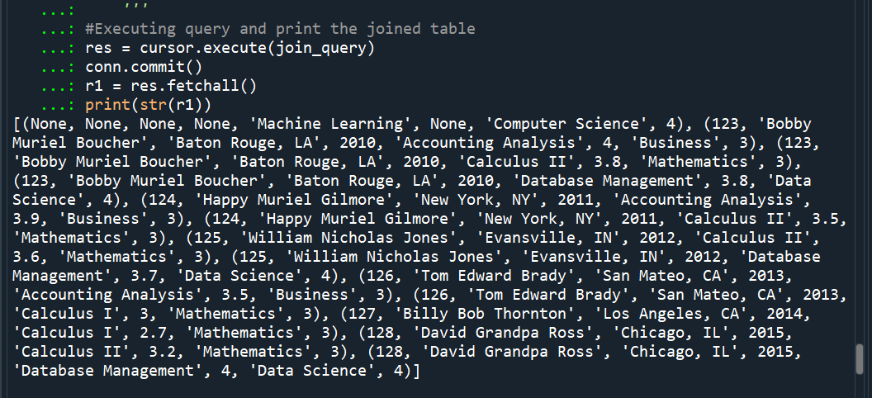
- Write python code that uses that view to export all data into a single .txt file (that is a “de-normalized” 1NF file with some redundancy present)
Include a screenshot of the output .txt file (in addition to the python code)
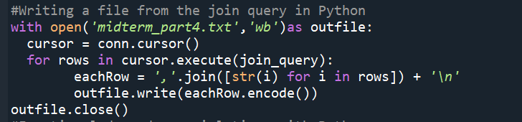
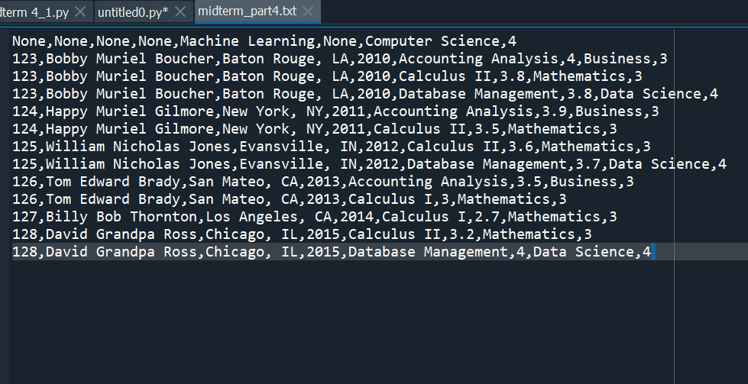

- Add a new row to the de-normalized .txt file (you can manually edit the .txt file from part b) that violates the following functional dependency:
CName → Credits
(you can do so by creating a new record that repeats the course name but does not match the number of credits associated with this course)
I have added a new student manually to the file (LeBron James) and he is in a Calculus class that violates the functional dependency as it is a 3hr class and in the file it is now incorrectly marked 4hr class.
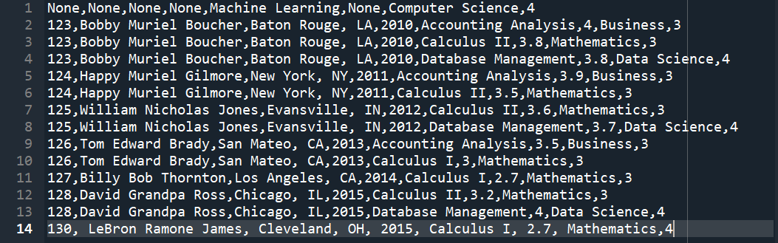

- Write python code that will identify the values for which functional dependency was violated (hint: when the functional dependency is valid, there is only one unique value of Credits for each CName). Your solution should detect any violation of the CName → Credits functional dependency, not just your example. Keep in mind that functional dependency is violated only in the pre-joined .txt file, not in the SQLite database.
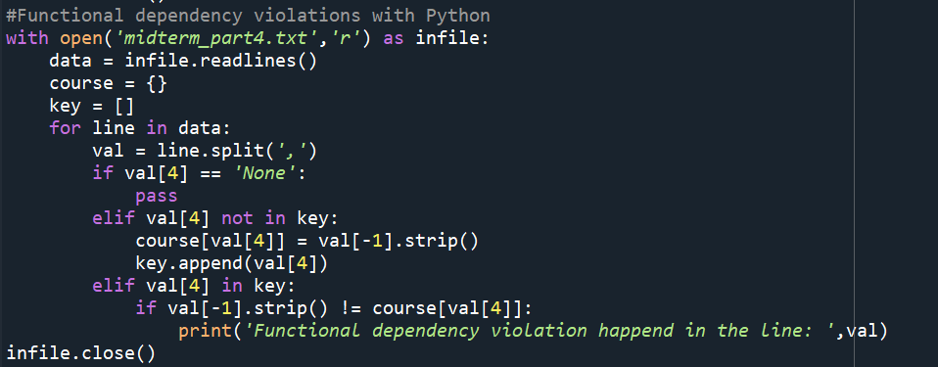
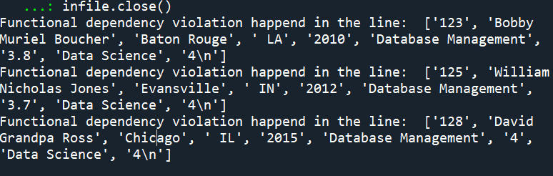

- Suppose I have a query Q1: For every department, display the average grade.

  - Use the view from Part 4-a to re-write Q1 query (i.e., replace the tables in the query’s FROM clause by the view and rewrite the rest of the query accordingly).
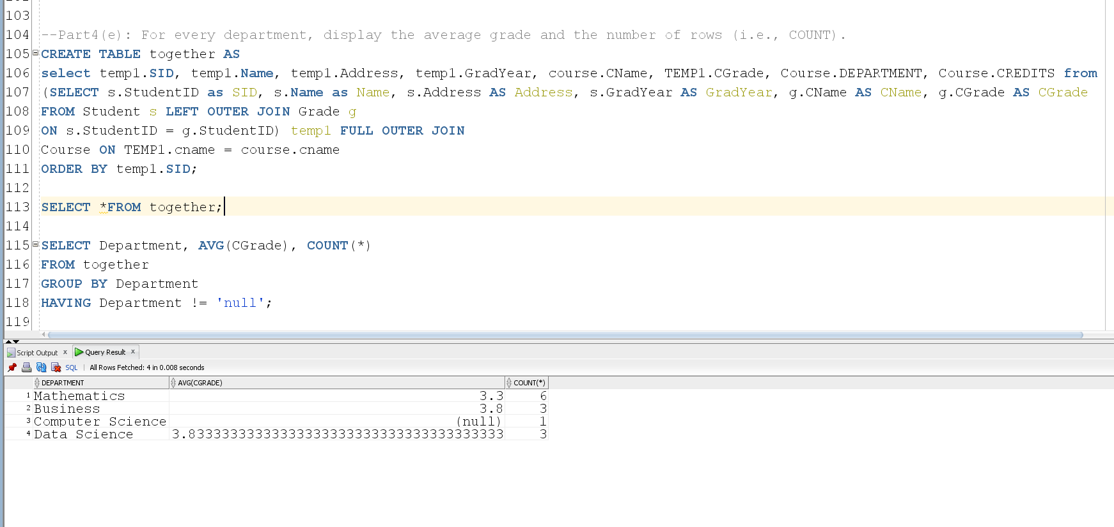

  - Use the single .txt file containing de-normalized data from part-b to answer Q1 with python instead of SQL. Note that this solution should not use SQLite or SQL.

